ACTIVITY | EXPLICATION | DURATION | MATERIAL
Abs | Classic abs  Lying on the floor. We rise and low slowly with our hands in the neck. We let the air go up. | x10 | Mat
Abs | Same as before but every time when we go up we stand up 3’’ | x15 | Mat
Abs | Lying on the floor. Right(left) elbow touches left (right) knee. We keep our right (left) leg straight. | x25 | Mat
Abs (inferiors) | Lying on the floor. We keep our legs in 90º position and we took our legs to the belly. | x15 | Mat
Abs | Classic abs position. We touch our heels | x20 | Mat
Plank | Planch position. We move up and down our left leg. | x20 | Mat
Plank | Planch position. We move up and down our right leg. | x20 | Mat
Buttocks exercises | Lying on the floor with my legs bent and I go up and down the pelvis. | x15 | Mat
 | Same but in 2 times | x15 | Mat
Buttocks exercises | Lying on the floor sideways. We up and down our right leg. | x15 | Mat
 | Same but in 2 times. | x10 | Mat
 | We took our knee to the chest. | x10 | Mat
 | We “kick” forward | x10 | Mat
Buttocks exercises | Lying on the floor sideways. We up and down our left leg. | x15 | Mat
 | Same but in 2 times. | x10 | Mat
 | We took our knee to the chest. | x10 | Mat
 | We kick” forward | x10 | Mat
Squat | Classic squats | x10
 | Same but when we are down we touch the floor with our hands | x10
Dumbbell split squat | 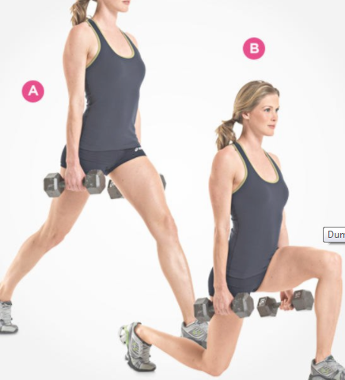 | x10  with each leg
Stretching | 